November Legislative Committee Report
By Dick Simpson

There is a lot beginning to happen. While there have been no key votes on pension or our health care issues in the legislative veto session, there are key issues for us to lobby on.
- As you saw in SUAA blast email, in a resounding vote of 327 to 75, the U.S. House of Representatives passed H.R. 82 aka "The Social Security Fairness Act," which would repeal the Windfall Elimination Provision (WEP) and Government Pension Offset (GPO).
A bill rarely receives such strong bi-partisan support, but this was one of those times. Of the 17 members of the Illinois Congressional Delegation, only two representatives, Mary Miller and Darin Lahood, voted against the bill.
WEP and GPO have long been a major concern for many of our members, and we are one step closer to seeing both programs repealed.
Now that the bill has passed the House, it will move on to the U.S. Senate, where, in more good news, the Senate version of the Social Security Fairness Act has 62 co-sponsors. If all of the Senate co-sponsors were to vote to "invoke cloture," which requires a 60-vote threshold, it would end all debate on the bill, and the bill would go straight to a vote for final passage. Should the bill pass the Senate, it would then go to President Biden to sign into law or veto it. It is important to contact our two Illinois Senators, and we should probably send a blast email to all of our UIC members to do so.
- Attached to the report is the flyer on the Fair Retirement and Recruitment Act which will be our major lobbying effort in the spring session. I have copied the main points at the end of this report.
- It is important to realize that there is a $3 billion budget gap for the State so that we will need to fight for university and our pension funding this year.

Illinois has a problem: Unfair retirement benefits for teachers, firefighters, nurses, and other public service workers are so low that they do not provide a stable retirement. That poor retirement plan has made it difficult to hire the workers we need to serve our communities.

Politicians caused the problem when they created a lower "Tier 2" pension benefit for public workers hired after Jan. 1, 2011.
These unfair cuts make it difficult for retirees-many of whom can't participate in

Social Security-to pay for things like food and medicine, especially with high inflation.

Tier 2 members must pay just as much for their pension as those on the better Tier 1 plan. In fact, many pay more into the pension system than their benefit is worth. And most Tier 2 members can't retire before age 67.

But there's a solution. The Fair Retirement and Recruitment Act will begin to fix Tier 2, promoting retirement security, recruitment, and retention for public service workers across Illinois.
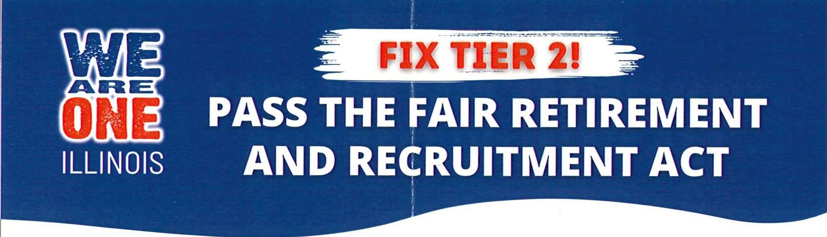

The Fair Retirement and Recruitment Act will:

Bring the final average salary pension calculation back in line with Tier 1.
Implement an across-the-board 3% simple cost-of-living adjustment for all Tier 2 members.
Align the Tier 2 retirement age requirements with Tier 1.
Adjust the pension salary cap to match the Social Security Wage Base, addressing the so-called "Safe Harbor" problem.

PUBLIC EMPLOYEES WORK HARci TO SERVE OUR COMMUNITIES.
:
WE SHOULD BE ABLE TO PAY!OUR BILLS IN RETIREMENT!
- LEARN MORE AT WWW.FIXTIER2.COM
- (§r-m._ :xrt•t•)

